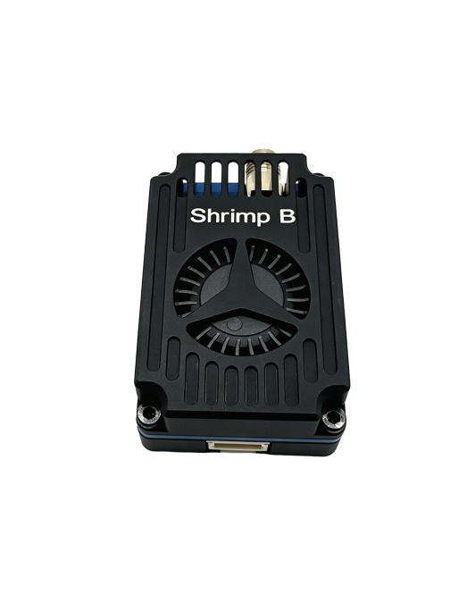
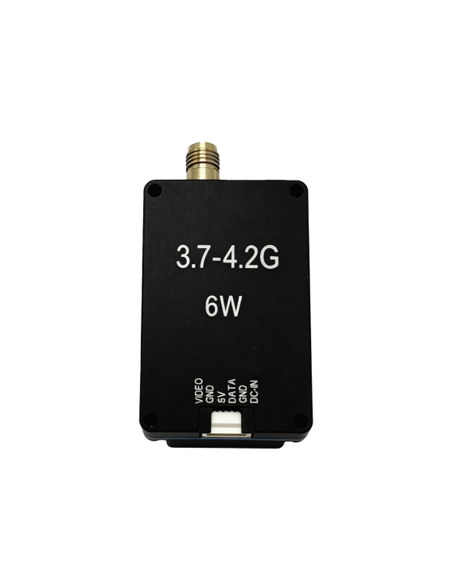

3.7-4.2GHz 6W VTX Video Transmitter Shrimp B

Key Features
- None standard frequency from 3.7G to 4 .2G for less congestion .
- Designed for long-range flights , up to 6W transmitting power, and provide multi-level adjustment.
- Efficient PA and power calibration to ensure power consistency across all channels .
- Customized digital PLL circuit , chip level integration , no frequency drift.
- Aluminum alloy three-layer shell structure and large
centrifugal fan provide sufficient heat dissipation to ensure stable output of transmitting power.
- 32 channels supports band switching within the 3.7–4 .2GHz range .

General Characteristics
Frequency band | 3700-4320 MHz | Output power | 25mW/200mW/1W/6W
Channel | 32 CH | Frequency precision | ±200KHz (Typ.)
Modulation type | FM | Power Supply | DC 7-36V
Frequency control | PLL | Video input level | 1V±0.2Vp-p (typ.)
Control Protocol | IRC Tramp | S/N(For ±3MHz) | >55dBc
Antenna | SMA 50 Ohms | Operating Temperature | -10℃~+70℃
Dimension | 44*28.6* 14.7mm | Weight | 25.3g

Frequency table
BAND | CH1 | CH2 | CH3 | CH4 | CH5 | CH6 | CH7 | CH8
BANDA | 3700 | 3720 | 3740 | 3760 | 3780 | 3800 | 3820 | 3840
BAND b | 3860 | 3880 | 3900 | 3920 | 3940 | 3960 | 3980 | 4000
BAND C | 4020 | 4040 | 4060 | 4080 | 4100 | 4120 | 4140 | 4160
BAND d | 4180 | 4200 | 4220 | 4240 | 4260 | 4280 | 4300 | 4320

RF Power
Value | 25 | 200 | 1000 | 5000
Power level | 25mW | 200mW | 1W | 5W
Gain | 14dBm | 23dBm±0.5 | 30dBm±0.5 | 38dBm±0.5

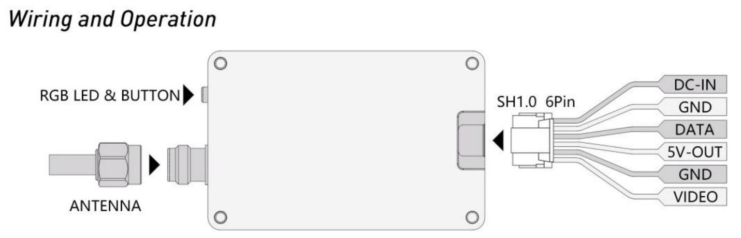
Button Operation
- Controlled using a single button , the button integrates RGB lighting , blue for band , red for channel , and green for power level.
- When there is no operation , the RGB LED blinks cyclically, the number of times the RGB blinks represents the current VTX status (when the green LED is always on , the VTX
enters PITMODE) .
- Long press the button to enter VTX setting , at this time the RGB lights are lit alternately, release the button under the corresponding color light to enter the corresponding function setting. At this time , short press the button to adjust the value .
For setup via the flight controller, connect the DATA pin and use the IRC Tramp protocol.
Attention

Antenna must be connected before use! Otherwise there is a risk of damage to the product.
The product needs to be mounted reliably, avoiding vibration and high temperatures . The product has a built-in power filter, but still need to avoid excessive power supply interference .

